Multi-Asset Commodity Risk Premia: Research Summary
Metals, Energy, Precious Metals, NGL, Agriculture, Correlation Analysis, and Cross-Commodity Portfolio
Basis of all results: daily returns net of 5 bp round-trip transaction costs, 1 January 2012 to 23 September 2026. Return is the annualised compound return, Vol the annualised volatility and IR their ratio (no risk-free rate). Equal Weight (EW PORT) averages the components equally; Inverse Vol weights each component by the inverse of its trailing 63-day volatility, lagged one day. Periods (regimes): P1 2012-2016, P2 2017-2021, P3 2022-2026. Signals are those of the main analysis, except that Value starts after 504 observations of F3 (two years), so that NGL Value is live before 2012. Energy includes Natural Gas unless stated.

Key Findings
- NGL is the strongest sleeve in the research: Equal Weight (IR +1.21) and Inverse Vol (IR +1.14) are more than double the best of any other asset class, and Momentum, Carry, and Carry-Momentum are each positive in every period, as they are in Energy.
- Energy's Carry-Momentum is its strongest strategy (IR +0.60), and Value (IR -0.14) is the only Energy strategy with a negative full-sample IR; excluding Natural Gas improves every sleeve and lifts the Equal Weight portfolio from IR +0.54 to +0.62.
- In Metals, Value is the only strategy with a clear edge (IR +0.38); both portfolio constructions (Equal Weight -0.06, Inverse Vol +0.09) underperform simply holding Value alone, since blending in three strategies with little or no edge dilutes the one signal that works.
- Precious Metals and Agriculture are the two asset classes where portfolio construction fails: neither earns a positive IR (Precious Metals Equal Weight -0.34, Inverse Vol -0.38; Agriculture -0.18 and -0.17), and in both every strategy is net negative full-sample.
- Energy-NGL is the most correlated pair of asset classes for all six series types (EW PORT correlation 0.33) and Metals-Precious Metals the second most correlated under EW PORT (0.15), yet standalone Energy-NGL is the best-performing of the ten pairs (Equal Weight IR +1.07, Inverse Vol +1.05), proving correlation and performance are separate questions.
- The cross-commodity portfolio (each strategy equal-weighted across the five asset classes, then the four strategies combined) delivers Equal Weight IR +0.69 and Inverse Vol IR +0.75 at a volatility of 5.5%, is positive in every period under both constructions, and is negatively correlated with equity (-0.17), a traditional 60/40 portfolio (-0.17) and even a passive commodity index (-0.05), genuine diversification, not repackaged beta.

Metals
- Momentum (Return -4.7%, Vol 14.7%, Max Drawdown -60.6%, IR -0.32): negative in P1 (IR -0.43) and P3 (-0.55) and roughly flat in P2 (+0.05). The P3 losses are in Lead (-1.15), Zinc (-0.51) and Copper (-0.32), the metals that spiked in 2021-2022 and then reversed sharply, which is the whipsaw a trend signal cannot avoid; only Aluminium made money in P3 (+0.64).
- Carry (Return +0.2%, Vol 11.3%, Max Drawdown -40.1%, IR +0.02) and Carry-Momentum (Return -0.9%, Vol 10.9%, Max Drawdown -58.7%, IR -0.08): both earn their positive results in P1 (IR +0.50 / +1.01) and turn negative in P2 (-0.39 / -0.69) and P3 (-0.04 / -0.52). The P1 Carry result is concentrated in Aluminium (IR +0.83) and Zinc (+0.77), the two metals whose curves were in the steepest contango of the period (average F1-F13 slope of -4.3% and -2.3%, backwardated on only 1% and 3% of days), the years of large LME stocks, aluminium financing deals and warehouse queues of more than two years (Reuters, LME). Contango eased from P2 (Aluminium -2.6% and -2.3%, Zinc +1.2% and +1.2%).
- Value (Return +4.1%, Vol 10.8%, Max Drawdown -27.3%, IR +0.38): the strongest strategy and the only one with a clear edge, positive in every period (P1 +0.34, P2 +0.08, P3 +0.76). It correlates at -0.50 with Momentum full-sample, the most negative pairing within the asset class and the strongest diversification relationship.
- The P3 Value result (+0.76) comes from the metals that overshot their five-year averages and fell back: Lead (+0.89), Zinc (+0.71) and Aluminium (+0.58). Aluminium peaked at $3,876 on 4 March 2022 as the energy crisis forced European smelter cuts (Fastmarkets) and was down to $2,076 by December 2023, and Zinc fell from $4,523 in April 2022 to $2,240 in May 2023. Copper (+0.13) is the exception because it kept rising to a record $14,851 on 22 September 2026, which market reports tie to US tariff threats, tight concentrate supply and electrification demand.
- Portfolio construction: Equal Weight (Return -0.4%, Vol 6.3%, Max Drawdown -25.9%, IR -0.06) and Inverse Vol (Return +0.5%, Vol 5.8%, Max Drawdown -19.0%, IR +0.09) both underperform holding Value alone (Return +4.1%, Vol 10.8%, Max Drawdown -27.3%, IR +0.38) on IR. Inverse Vol has the shallower drawdown and lower volatility of the two, but neither approaches Value's IR.
- Individual-metal decomposition: Momentum's blended IR of -0.32 masks a single working metal. Aluminium alone returns IR +0.22, the only positive result among the four, while Copper, Zinc, and Lead are all negative (Lead as low as -0.56). Value shows the opposite pattern, positive in every metal individually (+0.09 to +0.42), with blended volatility of 10.8% well below the roughly 15.9% average held by any one metal alone.
- Why neither construction beats Value: diversification only adds value when it combines more than one genuine edge. Value is the only strategy with a clear edge (IR +0.38); Carry adds nothing (+0.02) and Momentum (-0.32) and Carry-Momentum (-0.08) are negative, so blending them with Value dilutes the one real signal in the book instead of diversifying real risk. The same logic applies within a strategy: blending Momentum across metals dilutes Aluminium's one working signal, while blending Value across metals, where every metal carries a positive edge, lifts the IR above the average single metal (+0.38 against +0.26).
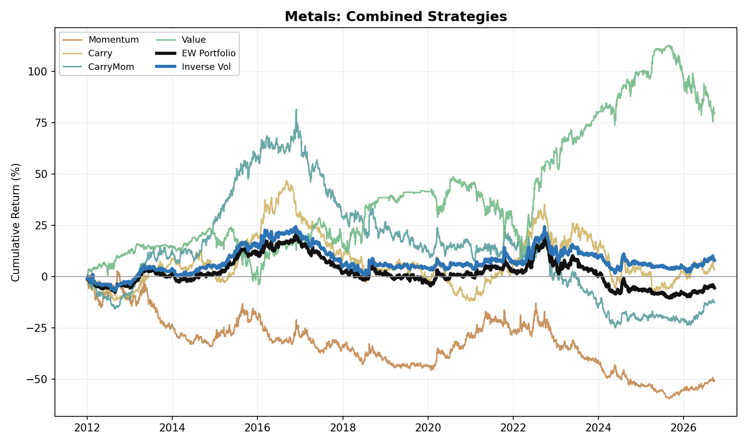
Figure 1. Metals: Combined Strategy Performance (Cumulative Return, 2012-2026)

Energy
- Carry-Momentum (Return +12.8%, Vol 21.2%, Max Drawdown -26.3%, IR +0.60) is the strongest individual strategy in the Energy basket and, like Momentum and Carry, is positive in every period (Carry-Momentum P1 +0.63, P2 +0.53, P3 +0.71), the clearest evidence in Energy that term-structure changes carry genuine, repeatable information.
- Momentum (Return +14.1%, Vol 28.5%, Max Drawdown -55.4%, IR +0.50): positive in every period (P1 +0.63, P2 +0.64, P3 +0.24), with most of its return earned in a few large directional moves: calendar years 2014, 2015, 2020 and 2021 account for 95% of its cumulative log return. They coincide with the 2014-2016 price collapse (WTI fell from $105 in June 2014 to $26 in February 2016, after OPEC's November 2014 decision to hold output against rising US shale supply), the 2020 demand collapse and the 2021 recovery. P3 is its weakest period even though it contains the March 2022 spike to $124 after Russia's invasion of Ukraine (a further 14% of the total). The war between the United States, Israel and Iran that began on 28 February 2026 then disrupted Gulf supply on a scale the IEA calls the largest in the history of the oil market, and Brent futures went from $72 on 27 February to $118 on 31 March; the first nine months of 2026 alone are 23% of the sleeve's cumulative log return.
- Carry (Return +7.3%, Vol 25.2%, Max Drawdown -53.9%, IR +0.29) is positive in every period (P1 +0.47, P2 +0.42, P3 +0.02) and weakest in P3 (IR +0.02), where crude oil is the problem (WTI -0.23, Brent -0.31, against Heating Oil +0.87) although the curves were the most backwardated of the sample (WTI F1-F3 backwardated on 87% of days in P3 against 24% in P1 and 46% in P2). The V2 signal is measured against each curve's own trailing 252-day slope, so a high level of backwardation does not by itself produce Carry returns.
- Value (Return -3.7%, Vol 26.9%, Max Drawdown -70.4%, IR -0.14) is the one consistent drag on a full-sample basis, negative in P1 (IR -0.40) and P3 (-0.13) and marginally positive in P2 (+0.09). The 2014-2016 price collapse (WTI from $105 to $26), triggered by US shale supply growth and OPEC's decision to hold output, behaves as a persistent trend rather than a mean-reverting cycle, exactly the environment a reversion strategy is built to lose in. It correlates at -0.49 with Momentum and -0.49 with Carry, the same diversification relationship seen in Metals (-0.50 with Momentum).
- Portfolio construction: Equal Weight (Return +7.4%, Vol 13.7%, Max Drawdown -27.8%, IR +0.54) and Inverse Vol (Return +7.2%, Vol 13.6%, Max Drawdown -27.5%, IR +0.53) are almost identical and both positive in every period (Equal Weight P1 +0.52, P2 +0.82, P3 +0.31; Inverse Vol P1 +0.50, P2 +0.79, P3 +0.31). Unlike Metals, where Inverse Vol lifts the portfolio, the choice of weighting makes no material difference in Energy.
- Excluding Natural Gas (Energy ex-NatGas) improves every sleeve: Momentum +0.50 to +0.53, Carry +0.29 to +0.34, Carry-Momentum +0.60 to +0.65, Value -0.14 to -0.11 (IR). Equal Weight (Return +9.8%, Vol 15.7%, Max Drawdown -28.7%, IR +0.62) and Inverse Vol (Return +10.0%, Vol 15.5%, Max Drawdown -27.0%, IR +0.64) rise accordingly (from IR +0.54 and +0.53 with Natural Gas).
- Individual-product decomposition: Momentum and Carry-Momentum work across WTI, Brent, RBOB, and Heating Oil (IR +0.29 to +0.65) but carry no edge in Natural Gas (IR +0.02 and 0.00), consistent with gas's weather- and basis-driven price action decoupling from the broader term-structure logic: the Natural Gas curve was in contango on 87%, 75% and 74% of days in the three periods, and Henry Hub averaged $2.77 in 2012, the lowest since 1999, on a mild winter, record storage and rising shale output (EIA). Value is negative in four of the five products (IR -0.07 to -0.23) and flat in Brent (+0.02), a broad, structural failure, not a concentration issue the way Momentum's weakness in Metals was.
- Physical storage bottlenecks, pipeline capacity limits, and producers' structural need to hedge downside force the market to pay a continuous insurance premium to whoever takes the other side of that risk, the same economic logic that shows up as Carry-Momentum's clean, all-period positive record above.
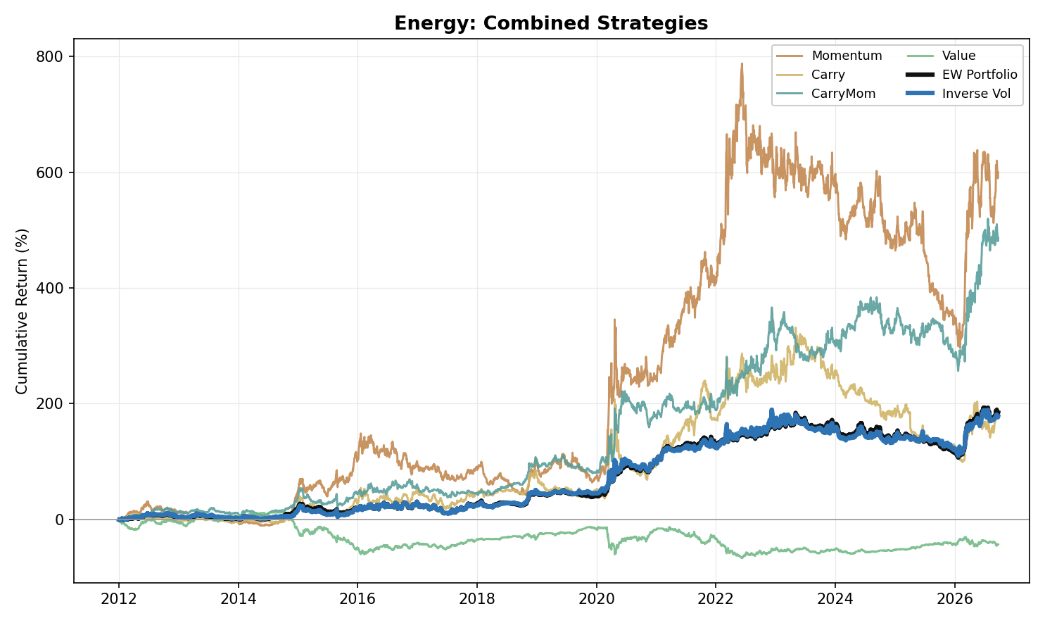
Figure 2. Energy: Combined Strategy Performance (Cumulative Return, 2012-2026)

Precious Metals
- Momentum (Return -4.9%, Vol 20.6%, Max Drawdown -73.2%, IR -0.24) is flat in P1 (IR +0.06) and negative in P2 (-0.46) and P3 (-0.29). Precious Metals are priced primarily off macro drivers, above all real yields (the weekly correlation of gold returns with changes in the 10-year real yield, FRED series DFII10, is -0.39 over the sample, -0.64 in P2 and -0.25 in P3), currency-debasement expectations and tail-risk demand, not off their own recent price action, so trend-following has nothing to extract. Gold Momentum earned its two best years in the 2013 sell-off, when gold fell 28% on Fed tapering and ETF outflows (a log return of +0.25), and in the 2025 rally (+0.36), and little otherwise.
- Carry (Return -3.7%, Vol 15.3%, Max Drawdown -54.1%, IR -0.24) and Carry-Momentum (Return -1.3%, Vol 13.9%, Max Drawdown -58.4%, IR -0.09) show no consistent edge: Carry is negative in P1 (IR -0.26) and P2 (-0.48) and flat in P3 (-0.02), while Carry-Momentum is positive in P1 (+0.13) and P2 (+0.28) before turning negative in P3 (-0.53), consistent with the post-2022 higher-real-yield environment pushing the sector deeper into cost-of-carry contango: the 10-year real yield averaged 1.61% in P3 against 0.03% in P2, and Gold's F1-F7 curve averaged -4.5% in P3 against -1.8% in P2 and -0.6% in P1 (Silver F1-F6 -4.5%, -2.3% and -1.1%).
- The long tenor pair does not change that conclusion. Carry IR: previous single pair (F1-F3) -0.17, short pair F1-F2 -0.25, long pair alone -0.18, two-pair blend -0.24. Carry-Momentum IR: previous single pair -0.30, short pair -0.21, long pair alone +0.04, two-pair blend -0.09.
- Value (Return -1.1%, Vol 17.9%, Max Drawdown -55.2%, IR -0.06) carries no full-sample edge, and the pattern is mixed at the product level: Platinum is the only metal with a positive signal (IR +0.11), Silver (-0.06) and Palladium (-0.03) are flat, and Gold (-0.24) is negative. Gold's loss is a P3 loss (-0.61): Value shorts a metal that trades more than 10% above its five-year average, and gold rose from $1,662 at the end of September 2022 to $4,341 at the end of 2025, with central banks buying 863 tonnes in 2025 against a 2010-2021 annual average of 473 tonnes (World Gold Council). The sleeve lost 0.45 in log return in 2025 alone.
- Portfolio construction: Equal Weight (Return -2.8%, Vol 8.2%, Max Drawdown -44.4%, IR -0.34) and Inverse Vol (Return -3.0%, Vol 8.0%, Max Drawdown -48.2%, IR -0.38) are both net negative full-sample, flat in P1 (0.00 / -0.18) and clearly negative in P2 (-0.49 / -0.48) and P3 (-0.48 / -0.47). Precious Metals is, with Agriculture, one of the two asset classes where every strategy is net negative full-sample and neither construction earns a positive IR.
- Individual-metal decomposition: Momentum has no edge in any metal (Gold +0.03, Silver -0.05, Platinum -0.15, Palladium -0.37). Carry is flat in Gold (+0.01), Silver (+0.02) and Platinum (+0.11); its negative blended IR comes from Palladium (-0.55), which is also the weakest metal for Momentum and Carry-Momentum (-0.35). Value's only positive edge sits in Platinum (IR +0.11).
- Fundamentally, gold producers hedge little (the global producer hedge book was 218 tonnes in Q3 2017 and 182 tonnes at the end of 2024, World Gold Council), so there are few commercial hedgers paying an insurance premium to transfer downside risk to financial counterparties; without that premium, Momentum has no structural engine to harvest here.
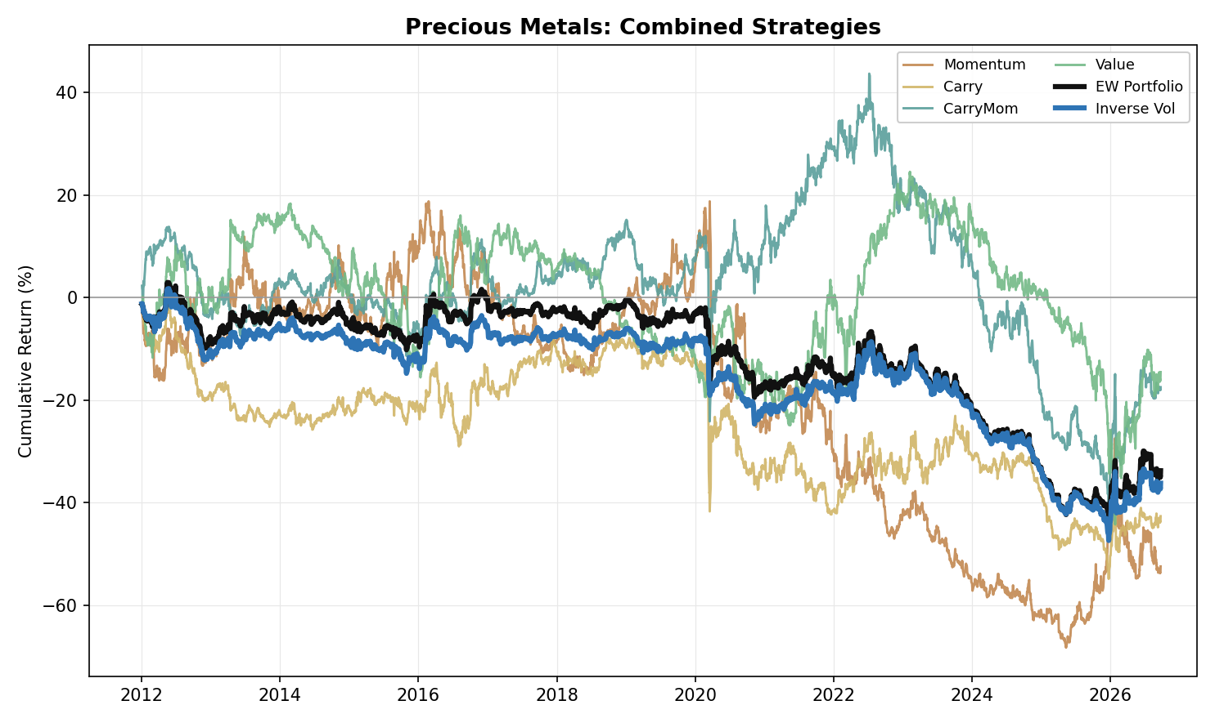
Figure 3. Precious Metals: Combined Strategy Performance (Cumulative Return, 2012-2026)

NGL
- NGL is the strongest sleeve in the research: Equal Weight (Return +16.7%, Vol 13.8%, Max Drawdown -19.0%, IR +1.21) and Inverse Vol (Return +15.4%, Vol 13.5%, Max Drawdown -21.7%, IR +1.14), the best full-sample IR of any asset class under both constructions. At the individual-strategy level, Momentum (IR +1.13), Carry (IR +0.91), and Carry-Momentum (IR +0.66) are positive in every one of the three periods. Value (Return +2.2%, Vol 26.7%, Max Drawdown -72.2%, IR +0.08) is the exception: net positive full-sample but negative in P1 (-0.41), flat in P2 (+0.05) and strongly positive in P3 (+0.87).
- NGL's portfolios are strong in every period rather than in one: Equal Weight IR is P1 +1.20, P2 +1.40, P3 +1.00 and Inverse Vol P1 +1.17, P2 +1.21, P3 +1.05. Both are well ahead of every other asset class, whose best full-sample Equal Weight IR is +0.54 (Energy). The macro backdrop is the US export build-out: in 2012 Mont Belvieu propane traded at an average $0.89/gal discount to international prices because export terminals were at capacity (Hydrocarbon Engineering), and by 2024 propane exports averaged about 1.8 million b/d, with a record 2.011 million b/d in November, almost three times a decade earlier, while ethane exports reached 492,000 b/d against 65,000 b/d in 2015 and butane 491,000 b/d against 97,000 (OPIS, citing EIA).
- Carry (Return +20.3%, Vol 22.4%, Max Drawdown -41.1%, IR +0.91) is the clearest embodiment of NGL's seasonal mechanics: predictable weather- and industrial-driven demand cycles push futures curves from contango in low-demand build periods into steep backwardation as inventories drain in peak season. In the data the F2-F4 slope averages +3.8% (backwardation) in December to March and -1.6% (contango) in June to September. Carry is positive in every period (IR +0.45 to +1.45), capturing that swing.
- The two portfolio constructions are close, with Equal Weight ahead on return, drawdown and IR: Equal Weight returns +16.7% against +15.4% for Inverse Vol, with a shallower maximum drawdown (-19.0% against -21.7%) and a higher IR (+1.21 against +1.14), at a volatility only marginally higher (13.8% against 13.5%).
- The P3 Value result (+0.87) is not a one-year event: the sleeve earns a positive log return in each of 2022 to 2026, and 2026 is its best year of the period (+0.36, against +0.09 in 2025). It is led by Propane (+1.47) and Butane (+1.09). The war that began on 28 February 2026 and the closure of the Strait of Hormuz disrupted nearly 40% of global LPG export supply and sent US LPG exports sharply higher (OPIS, 10 June 2026); in our series the Propane front month rose from $0.67/gal on 27 February to $0.90/gal on 27 March.
- Individual-product decomposition: Momentum works uniformly across all four products (IR +0.67 to +1.10), the highest weakest-product result of any strategy in any asset class in the research. Carry (IR +0.34 to +0.94) and Carry-Momentum (IR +0.09 to +0.73) are also positive in every product. Value's modest full-sample edge is concentrated in Butane and Isobutane (IR +0.26 / +0.17), while Ethane and Propane show none (IR -0.10 / +0.01), the same split that explains Value's period-to-period inconsistency above.
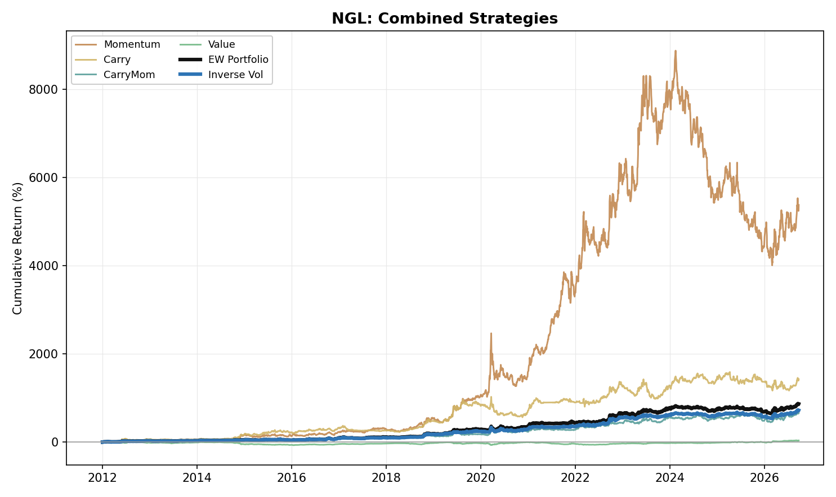
Figure 4. NGL: Combined Strategy Performance (Cumulative Return, 2012-2026)

Agriculture
- Agriculture (six products: Corn, Wheat, Soybean, Soybean Oil, Coffee, Sugar) has no edge in any sleeve: all four strategies are net negative full-sample, and Equal Weight (Return -1.1%, Vol 6.1%, Max Drawdown -31.7%, IR -0.18) and Inverse Vol (Return -1.1%, Vol 6.0%, Max Drawdown -29.0%, IR -0.17) follow. Together with Precious Metals it is one of the two asset classes where neither portfolio construction earns a positive IR.
- Momentum (Return -1.6%, Vol 12.8%, Max Drawdown -47.7%, IR -0.12) is negative in P1 (IR -0.16) and P3 (-0.31) and marginally positive in P2 (+0.11). By product it fails in Corn (-0.25), Wheat (-0.22), Soybean (-0.09) and Sugar (-0.07) and works only modestly in Soybean Oil (+0.12) and Coffee (+0.12).
- Carry (Return -0.5%, Vol 9.9%, Max Drawdown -33.3%, IR -0.05) and Carry-Momentum (Return -1.0%, Vol 10.0%, Max Drawdown -37.5%, IR -0.10) earn a positive IR in P1 (Carry +0.03, Carry-Momentum +0.34) and P2 (+0.48 / +0.20) and are at their worst in P3 (-0.67 / -0.78). Coffee is the swing: Carry-Momentum in Coffee returns IR +1.31 in P2, when the July 2021 Brazilian frosts lifted arabica by 32% in a week to its highest front-month price since October 2014 (Reuters, Bloomberg), and -0.89 in P3 (Carry -0.72), after the price reached a record $4.39/lb on 13 February 2025 and fell back to $2.76/lb by 23 September 2026 in our series.
- The long tenor pair matters little for the result. Carry IR: previous single pair (F1-F2) -0.23, long pair alone +0.14, two-pair blend -0.05. Carry-Momentum IR: previous single pair +0.03, long pair alone -0.20, two-pair blend -0.10.
- Value (Return -1.3%, Vol 12.9%, Max Drawdown -47.9%, IR -0.10) is flat to negative: flat in P1 (IR -0.01), negative in P2 (-0.24) and P3 (-0.07). Corn explains much of the P1 weakness in the individual products: Corn Value has an IR of -0.51 in P1 and loses in every year from 2012 to 2016 (log returns of -0.03, -0.20, -0.05, -0.19, -0.12), starting with the 2012 US drought that pushed corn to a record, with USDA projecting record season prices in August 2012. Value shorts a market that trades more than 10% above its five-year average.
- Portfolio construction: Equal Weight is positive in P1 (+0.06) and P2 (+0.22) and Inverse Vol in P2 (+0.22) only (-0.03 in P1); both are clearly negative in P3 (-0.76 / -0.67), and the P3 losses drive the negative full-sample result. P3 opens with the Russia-Ukraine price spike and its reversal: Wheat peaked at $14.25/bu on 7 March 2022 and was $7.09 by 23 September 2026, Corn went from $8.18 on 29 April 2022 to $5.29 and Soybean Oil from 90.6 cents/lb on 28 April 2022 to 67.3, while the FAO food price index peaked in March 2022 and fell through 2023. Sharp spikes followed by reversals, in grains in 2022 and in coffee in 2024-2025, are the pattern signals built on trend and curve slope handle worst.
- Individual-product decomposition: no sleeve works across the six products. The best single product-sleeve result is Coffee Carry-Momentum (IR +0.14) and the three weakest are Wheat Carry-Momentum (-0.30), Corn Value (-0.30) and Corn Momentum (-0.25); no product-sleeve result is above +0.14.
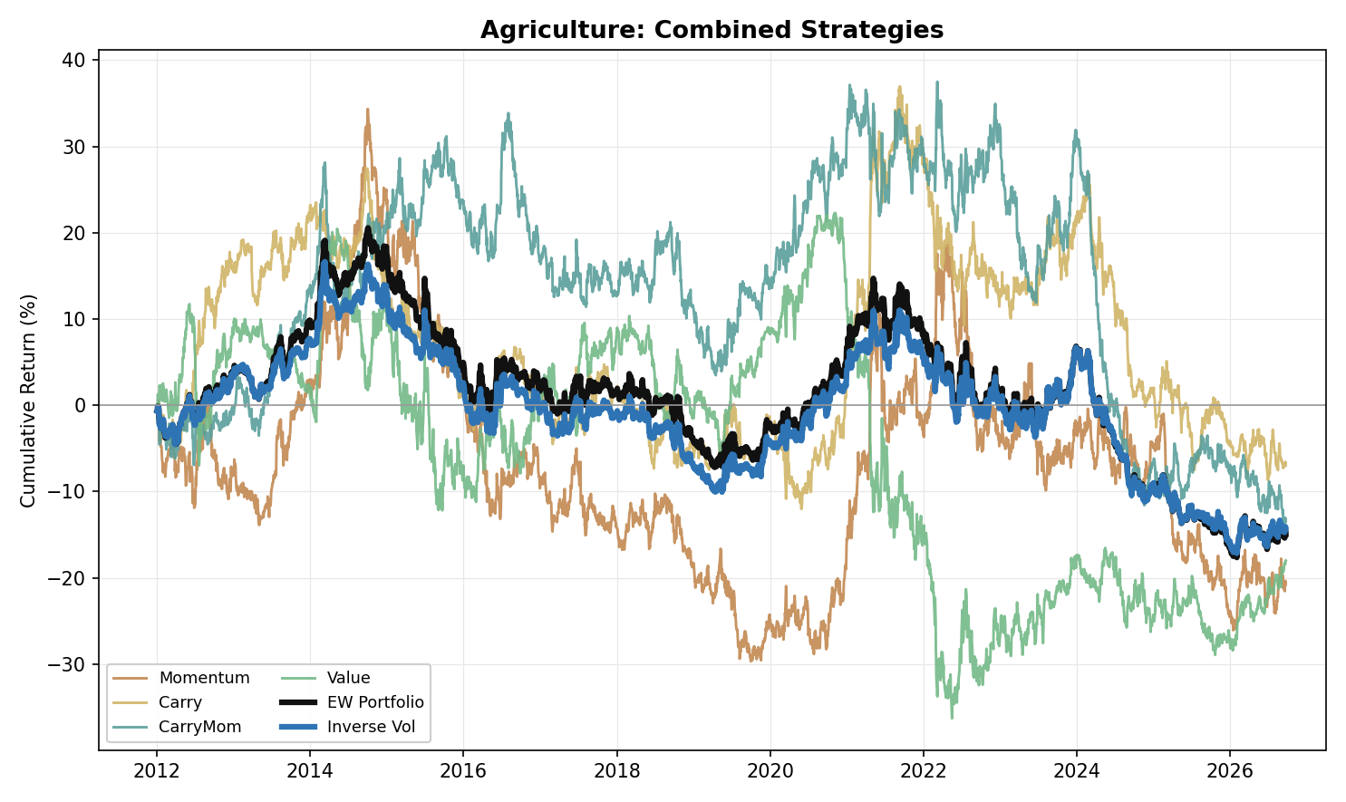
Figure 5. Agriculture: Combined Strategy Performance (Cumulative Return, 2012-2026)

Correlation Analysis

Within-Asset-Class Correlation
- Value is the least correlated sleeve with its own EW PORT in every asset class, correlating at only +0.03 in Metals, -0.10 in Energy, +0.03 in NGL and +0.04 in Precious Metals. Agriculture is the weak case (+0.24), where Value works against diversification more than anywhere else, though it is still the least correlated of the four sleeves there.
- Momentum and Carry are the most correlated pair of base strategies in Energy (0.68), NGL (0.66) and Agriculture (0.39), both moving with the same underlying trend signal. Metals and Precious Metals each break this pattern: in both, Carry and Carry-Momentum are the closest pair (0.41 in Metals, 0.57 in Precious Metals). Value is negatively correlated with Momentum in all five asset classes (-0.50 Metals, -0.49 Energy, -0.46 NGL, -0.41 Precious Metals, -0.29 Agriculture).
- Inverse Vol tracks its own Equal Weight portfolio closely everywhere, correlating between 0.96 and 0.99 across all five asset classes, expected since both portfolios are built from the same four sleeves and differ only in how they are weighted.

Cross-Commodity Correlation
- Energy and NGL are the most correlated cross-commodity pair for all six series types tracked: Momentum (0.46), Carry (0.21), Carry-Momentum (0.17), Value (0.55), EW PORT (0.33) and Inverse Vol (0.31), both trading the same underlying hydrocarbon complex.
- Metals-Precious Metals is the second most correlated pair for Momentum (0.23), Value (0.27) and EW PORT (0.15), despite the two asset classes having different fundamental drivers. For the other three series the pairs behind Energy-NGL are weaker still (second place is Metals-NGL for Carry at 0.08, Energy-Agriculture for Carry-Momentum at 0.06 and Metals-Precious Metals for Inverse Vol at 0.10), and Metals-Precious Metals is essentially uncorrelated for Carry-Momentum (0.00).
- Carry-Momentum is the most genuinely diversifying strategy across commodities: its correlations to the same strategy in other asset classes average just 0.04 in magnitude, the lowest of the six series (Carry 0.06; the other four range 0.08 to 0.20), and none of its ten pairwise readings exceeds 0.17.

Portfolio Construction Implication
- The Cross-Pair tab shows all ten asset-class pairs. Under the EW PORT measure, Energy-NGL (0.33) and Metals-Precious Metals (0.15) are the two most correlated pairs; every other pair is at or below 0.11. The table below sets each pair's EW PORT correlation beside its full-sample IR under Equal Weight and Inverse Vol (Energy including Natural Gas).
Pair | EW PORT correlation | Equal Weight IR | Inverse Vol IR
Energy-NGL | 0.33 | +1.07 | +1.05
Metals-NGL | 0.10 | +1.00 | +0.95
NGL-Agriculture | 0.07 | +0.96 | +0.77
Precious Metals-NGL | 0.04 | +0.80 | +0.55
Metals-Energy | 0.09 | +0.45 | +0.47
Energy-Agriculture | 0.11 | +0.39 | +0.33
Energy-Precious Metals | 0.03 | +0.27 | +0.20
Metals-Agriculture | 0.04 | -0.17 | -0.08
Metals-Precious Metals | 0.15 | -0.29 | -0.16
Precious Metals-Agriculture | 0.07 | -0.37 | -0.40
- Correlation and standalone performance are separate questions. Held on its own, Energy-NGL, the most correlated pair, produces the highest full-sample IR of the ten pairs under both constructions (Equal Weight +1.07, Inverse Vol +1.05), while Precious Metals-Agriculture produces the lowest (-0.37 and -0.40). Two individually strong books can still make a poor diversification pairing simply because they move together.

Cross-Commodity Portfolio
- Diversifying each individual strategy across all five asset classes first (equal-weighted), then combining strategies, lifts every strategy above its worst individual asset-class showing: Momentum (Return +6.1%, Vol 12.5%, Max Drawdown -36.0%, IR +0.49), Carry (Return +4.5%, Vol 8.8%, Max Drawdown -26.4%, IR +0.51), Carry-Momentum (Return +4.7%, Vol 7.9%, Max Drawdown -24.7%, IR +0.60), Value (Return 0.0%, Vol 12.1%, Max Drawdown -44.6%, IR 0.00). The worst asset-class IRs for the same strategies are -0.32, -0.24, -0.10 and -0.14.
- At the top level, combining those four cross-commodity strategies gives Equal Weight (Return +3.8%, Vol 5.5%, Max Drawdown -18.8%, IR +0.69) and Inverse Vol (Return +4.1%, Vol 5.5%, Max Drawdown -17.2%, IR +0.75). Inverse Vol is the stronger construction, with the higher return and IR and the shallower drawdown at the same volatility.
- The cross-commodity book is positive in every one of the three periods under both constructions (Equal Weight P1 +0.98, P2 +1.03, P3 +0.17; Inverse Vol P1 +1.17, P2 +0.89, P3 +0.32). Among the single asset classes only Energy and NGL do the same, and both do so at more than twice the cross-commodity volatility (Equal Weight 13.7% and 13.8% against 5.5%).
- The weakest period for the cross-commodity book is P3 (Equal Weight IR +0.17, Inverse Vol +0.32), still positive but a fraction of the strength shown in P1 and P2. Within the strategies, P3 is the period in which Momentum turns negative (-0.07) while Carry (+0.04) and Carry-Momentum (+0.14) are barely positive and Value (+0.30) is the best sleeve.
- Excluding Natural Gas from Energy lifts the book to Equal Weight (Return +4.3%, Vol 5.8%, Max Drawdown -18.6%, IR +0.73) and Inverse Vol (Return +4.6%, Vol 5.8%, Max Drawdown -17.2%, IR +0.80). Combining in the opposite order, each asset class's four sleeves first and then the five asset-class portfolios, gives the identical Equal Weight result (IR +0.69); the three other weighting combinations give IRs of +0.58, +0.69 and +0.57 (sleeves Equal Weight / across Inverse Vol; sleeves Inverse Vol / across Equal Weight; Inverse Vol at both stages).
- Across all ten asset-class pairings, Energy-NGL is the best-performing combination under both constructions (Equal Weight +1.07, Inverse Vol +1.05) even though it is the most correlated pair. The only pairs with a negative full-sample IR under either construction are the three built from Metals, Precious Metals and Agriculture alone: Metals-Precious Metals (-0.29 / -0.16), Metals-Agriculture (-0.17 / -0.08) and Precious Metals-Agriculture (-0.37 / -0.40), and each is negative in both P2 and P3 under Equal Weight, consistent with those three asset classes' own EW PORT IRs of -0.06, -0.34 and -0.18. Energy-NGL is the most construction-robust pair (Equal Weight +1.07, Inverse Vol +1.05), followed by Metals-Energy (+0.45 and +0.47), while Inverse Vol's effect is otherwise uneven: it pulls down Precious Metals-NGL most (+0.80 to +0.55), consistent with inverse-vol weighting dialing down NGL's higher-volatility portfolio (13.8% against 8.2% for Precious Metals). Replacing Energy with Energy ex-NatGas lifts all four Energy pairs under Equal Weight.
- Benchmarked against traditional assets, the cross-commodity book is a genuine diversifier rather than repackaged commodity beta: both constructions correlate negatively with Equity (Equal Weight -0.17, Inverse Vol -0.18) and with a traditional 60/40 portfolio (-0.17, -0.18), stay close to zero against Fixed Income (-0.04, -0.03), and are slightly negatively correlated with a passive Commodity Index (-0.05, -0.05), confirming these are genuinely active long/short signals, not disguised long-only commodity exposure. Value is the exception, the only strategy positively correlated with Equity (+0.14), the 60/40 portfolio (+0.14) and the Commodity Index (+0.07); among the base strategies, Value is also the most negatively correlated with Gold (-0.13), while Momentum, Carry and Carry-Momentum are essentially uncorrelated with it (+0.01, -0.01, +0.01). The correlations use daily returns of the SPY, AGG, DBC and GLD ETFs (prices refreshed from Yahoo Finance on 12 October 2026) on the days they share with the strategy series, from 2012 to 23 September 2026. Full detail in the Appendix.
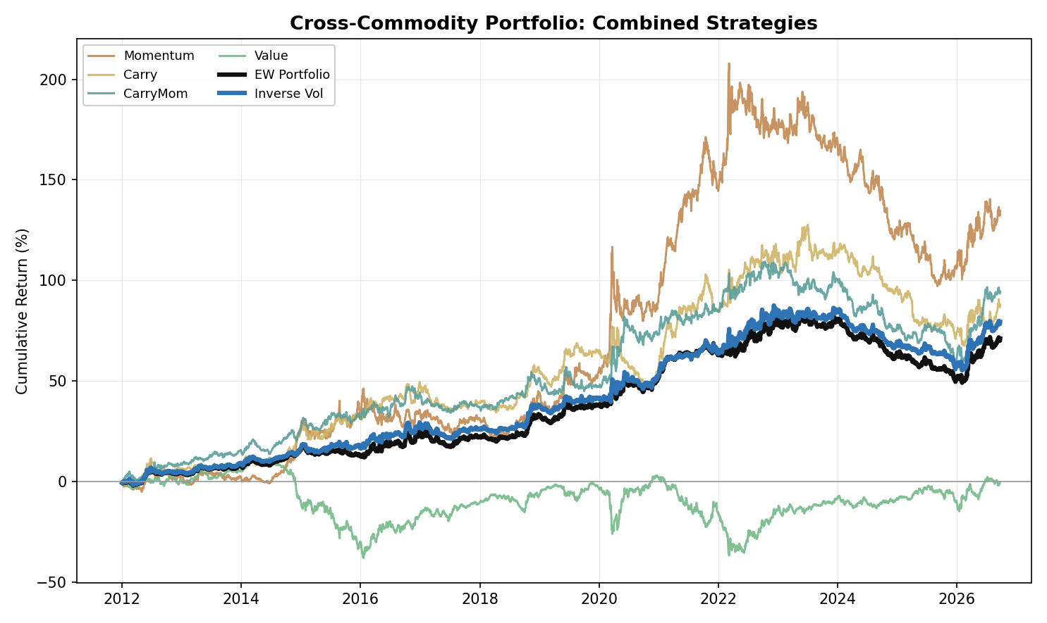
Figure 6. Cross-Commodity Portfolio: Combined Strategy Performance (Cumulative Return, 2012-2026)

Appendix: Period-Level Detail
Table A1. Metals: Strategy Information Ratios by Period
 | Full | 2012-16 | 2017-21 | 2022-26
Momentum | -0.32 | -0.43 | +0.05 | -0.55
Carry | +0.02 | +0.50 | -0.39 | -0.04
Carry-Momentum | -0.08 | +1.01 | -0.69 | -0.52
Value | +0.38 | +0.34 | +0.08 | +0.76

Table A2. Metals: Portfolio Construction Information Ratios by Period
 | Full | 2012-16 | 2017-21 | 2022-26
Equal Weight | -0.06 | +0.52 | -0.44 | -0.26
Inverse Vol | +0.09 | +0.71 | -0.44 | +0.03

Table A3. Metals: Individual-Metal Information Ratios, All Strategies (Full Sample)
 | Copper | Aluminium | Lead | Zinc
Momentum | -0.31 | +0.22 | -0.56 | -0.17
Carry | +0.09 | +0.28 | -0.30 | +0.02
Carry-Momentum | +0.06 | +0.04 | -0.16 | -0.10
Value | +0.09 | +0.15 | +0.42 | +0.38

Table A4. Energy: Strategy Information Ratios by Period
 | Full | 2012-16 | 2017-21 | 2022-26
Momentum | +0.50 | +0.63 | +0.64 | +0.24
Carry | +0.29 | +0.47 | +0.42 | +0.02
Carry-Momentum | +0.60 | +0.63 | +0.53 | +0.71
Value | -0.14 | -0.40 | +0.09 | -0.13

Table A5. Energy: Portfolio Construction Information Ratios by Period
 | Full | 2012-16 | 2017-21 | 2022-26
Equal Weight | +0.54 | +0.52 | +0.82 | +0.31
Inverse Vol | +0.53 | +0.50 | +0.79 | +0.31

Table A6. Energy: Individual-Product Information Ratios, All Strategies (Full Sample)
 | WTI | Brent | RBOB | HeatingOil | NatGas
Momentum | +0.49 | +0.42 | +0.29 | +0.65 | +0.02
Carry | +0.17 | +0.21 | +0.08 | +0.74 | -0.07
Carry-Momentum | +0.49 | +0.56 | +0.40 | +0.44 | 0.00
Value | -0.07 | +0.02 | -0.13 | -0.23 | -0.12

Table A7. Energy ex-NatGas: Strategy and Portfolio Information Ratios by Period
 | Full | 2012-16 | 2017-21 | 2022-26
Momentum | +0.53 | +0.57 | +0.66 | +0.37
Carry | +0.34 | +0.41 | +0.52 | +0.10
Carry-Momentum | +0.65 | +0.61 | +0.73 | +0.64
Value | -0.11 | -0.39 | +0.07 | -0.03
Equal Weight | +0.62 | +0.46 | +0.96 | +0.43
Inverse Vol | +0.64 | +0.44 | +0.97 | +0.47

Table A8. Precious Metals: Strategy Information Ratios by Period
 | Full | 2012-16 | 2017-21 | 2022-26
Momentum | -0.24 | +0.06 | -0.46 | -0.29
Carry | -0.24 | -0.26 | -0.48 | -0.02
Carry-Momentum | -0.09 | +0.13 | +0.28 | -0.53
Value | -0.06 | +0.05 | -0.07 | -0.13

Table A9. Precious Metals: Portfolio Construction Information Ratios by Period
 | Full | 2012-16 | 2017-21 | 2022-26
Equal Weight | -0.34 | 0.00 | -0.49 | -0.48
Inverse Vol | -0.38 | -0.18 | -0.48 | -0.47

Table A10. Precious Metals: Individual-Metal Information Ratios, All Strategies (Full Sample)
 | Gold | Silver | Platinum | Palladium
Momentum | +0.03 | -0.05 | -0.15 | -0.37
Carry | +0.01 | +0.02 | +0.11 | -0.55
Carry-Momentum | -0.04 | +0.16 | +0.13 | -0.35
Value | -0.24 | -0.06 | +0.11 | -0.03

Table A11. Precious Metals: Carry Tenor Pairs, Full-Sample Information Ratios
 | Previous single pair (F1-F3) | Short pair (F1-F2) | Long pair alone | Two-pair blend
Carry | -0.17 | -0.25 | -0.18 | -0.24
Carry-Momentum | -0.30 | -0.21 | +0.04 | -0.09

Table A12. NGL: Strategy Information Ratios by Period
 | Full | 2012-16 | 2017-21 | 2022-26
Momentum | +1.13 | +1.06 | +1.87 | +0.41
Carry | +0.91 | +1.45 | +0.81 | +0.45
Carry-Momentum | +0.66 | +0.65 | +0.59 | +0.80
Value | +0.08 | -0.41 | +0.05 | +0.87

Table A13. NGL: Portfolio Construction Information Ratios by Period
 | Full | 2012-16 | 2017-21 | 2022-26
Equal Weight | +1.21 | +1.20 | +1.40 | +1.00
Inverse Vol | +1.14 | +1.17 | +1.21 | +1.05

Table A14. NGL: Individual-Product Information Ratios, All Strategies (Full Sample)
 | Ethane | Propane | Butane | Isobutane
Momentum | +0.82 | +0.67 | +1.10 | +0.73
Carry | +0.34 | +0.94 | +0.69 | +0.65
Carry-Momentum | +0.09 | +0.59 | +0.73 | +0.57
Value | -0.10 | +0.01 | +0.26 | +0.17

Table A15. Agriculture: Strategy Information Ratios by Period
 | Full | 2012-16 | 2017-21 | 2022-26
Momentum | -0.12 | -0.16 | +0.11 | -0.31
Carry | -0.05 | +0.03 | +0.48 | -0.67
Carry-Momentum | -0.10 | +0.34 | +0.20 | -0.78
Value | -0.10 | -0.01 | -0.24 | -0.07

Table A16. Agriculture: Portfolio Construction Information Ratios by Period
 | Full | 2012-16 | 2017-21 | 2022-26
Equal Weight | -0.18 | +0.06 | +0.22 | -0.76
Inverse Vol | -0.17 | -0.03 | +0.22 | -0.67

Table A17. Agriculture: Individual-Product Information Ratios, All Strategies (Full Sample)
 | Corn | Wheat | Soybean | SoybeanOil | Coffee | Sugar
Momentum | -0.25 | -0.22 | -0.09 | +0.12 | +0.12 | -0.07
Carry | -0.12 | -0.07 | +0.01 | +0.04 | +0.01 | 0.00
Carry-Momentum | +0.11 | -0.30 | -0.11 | +0.03 | +0.14 | -0.13
Value | -0.30 | +0.09 | -0.11 | -0.08 | 0.00 | -0.02

Table A18. Agriculture: Carry Tenor Pairs, Full-Sample Information Ratios
 | Previous single pair (F1-F2) | Long pair alone | Two-pair blend
Carry | -0.23 | +0.14 | -0.05
Carry-Momentum | +0.03 | -0.20 | -0.10

Table A19. Cross-Commodity Portfolio: Correlation vs Traditional Assets (2012 to 23 September 2026)
 | Equity | Fixed Income | Commodity Index | Gold | 60/40 Portfolio
Momentum | -0.22 | -0.04 | -0.10 | +0.01 | -0.22
Carry | -0.17 | -0.04 | -0.01 | -0.01 | -0.18
Carry-Momentum | -0.14 | -0.03 | -0.07 | +0.01 | -0.14
Value | +0.14 | +0.02 | +0.07 | -0.13 | +0.14
EW Portfolio | -0.17 | -0.04 | -0.05 | -0.07 | -0.17
Inverse Vol | -0.18 | -0.03 | -0.05 | -0.05 | -0.18

Table A20. Cross-Commodity Portfolio: Strategy Information Ratios by Period (all 5 asset classes)
 | Full | 2012-16 | 2017-21 | 2022-26
Momentum | +0.49 | +0.57 | +0.96 | -0.07
Carry | +0.51 | +1.18 | +0.49 | +0.04
Carry-Momentum | +0.60 | +1.19 | +0.59 | +0.14
Value | 0.00 | -0.30 | +0.01 | +0.30

Table A21. Cross-Commodity Portfolio: Construction Information Ratios by Period (all 5 asset classes)
 | Full | 2012-16 | 2017-21 | 2022-26
Equal Weight | +0.69 | +0.98 | +1.03 | +0.17
Inverse Vol | +0.75 | +1.17 | +0.89 | +0.32
Equal Weight (ex-NatGas) | +0.73 | +0.95 | +1.11 | +0.24
Inverse Vol (ex-NatGas) | +0.80 | +1.12 | +0.99 | +0.38

Table A22. Cross-Pair Portfolio: Full-Sample Information Ratios, All Ten Asset-Class Pairs
 | Equal Weight | Inverse Vol
Metals-Energy | +0.45 | +0.47
Metals-Precious Metals | -0.29 | -0.16
Metals-NGL | +1.00 | +0.95
Metals-Agriculture | -0.17 | -0.08
Energy-Precious Metals | +0.27 | +0.20
Energy-NGL | +1.07 | +1.05
Energy-Agriculture | +0.39 | +0.33
Precious Metals-NGL | +0.80 | +0.55
Precious Metals-Agriculture | -0.37 | -0.40
NGL-Agriculture | +0.96 | +0.77

Table A23. Cross-Pair Portfolio: Energy Pairs Excluding Natural Gas, Full-Sample Information Ratios
 | Equal Weight | Inverse Vol
Metals-Energy (ex-NatGas) | +0.53 | +0.50
Energy (ex-NatGas)-Precious Metals | +0.37 | +0.33
Energy (ex-NatGas)-NGL | +1.10 | +1.13
Energy (ex-NatGas)-Agriculture | +0.48 | +0.40

Appendix: Equity-Curve Charts
Individual equity curves underlying the combined-strategy figures above, decomposed by instrument for each strategy within each asset class, and by asset-class pair, one chart per construction method, for the Cross-Pair Portfolios (Energy including Natural Gas).

Metals
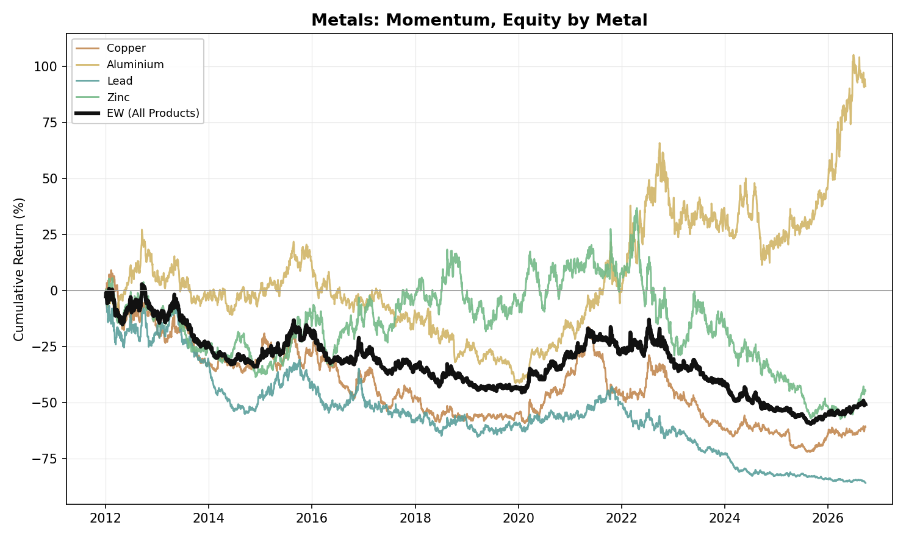
Figure A1. Metals, Momentum: Equity Curve by Metal (2012-2026)
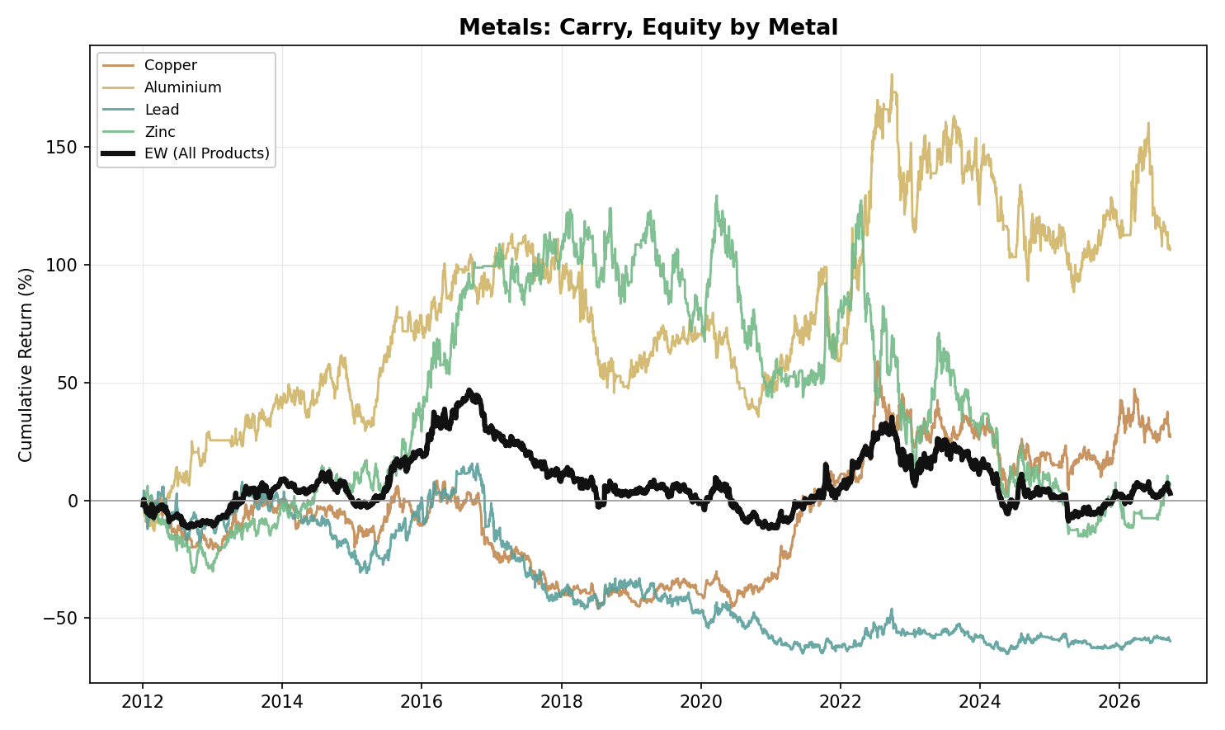
Figure A2. Metals, Carry: Equity Curve by Metal (2012-2026)
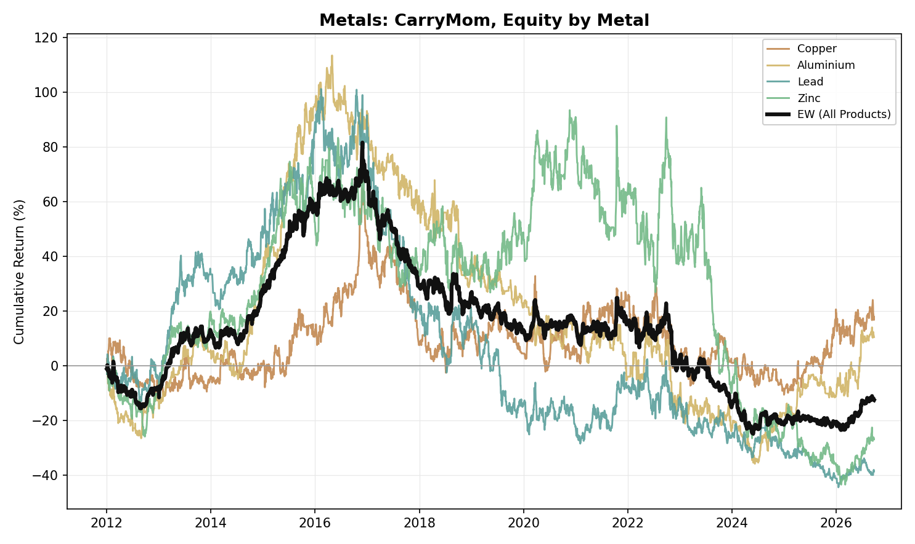
Figure A3. Metals, Carry-Momentum: Equity Curve by Metal (2012-2026)
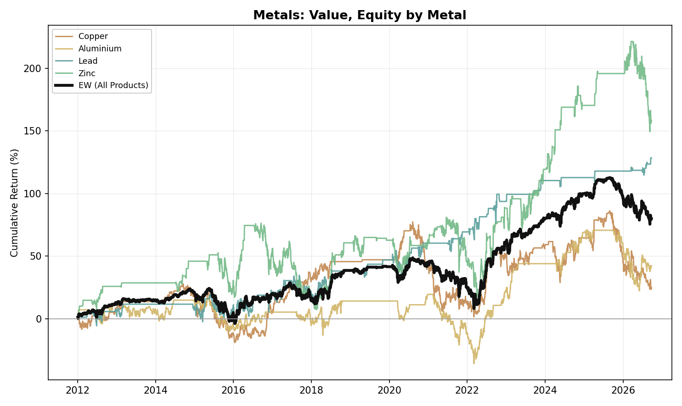
Figure A4. Metals, Value: Equity Curve by Metal (2012-2026)

Energy
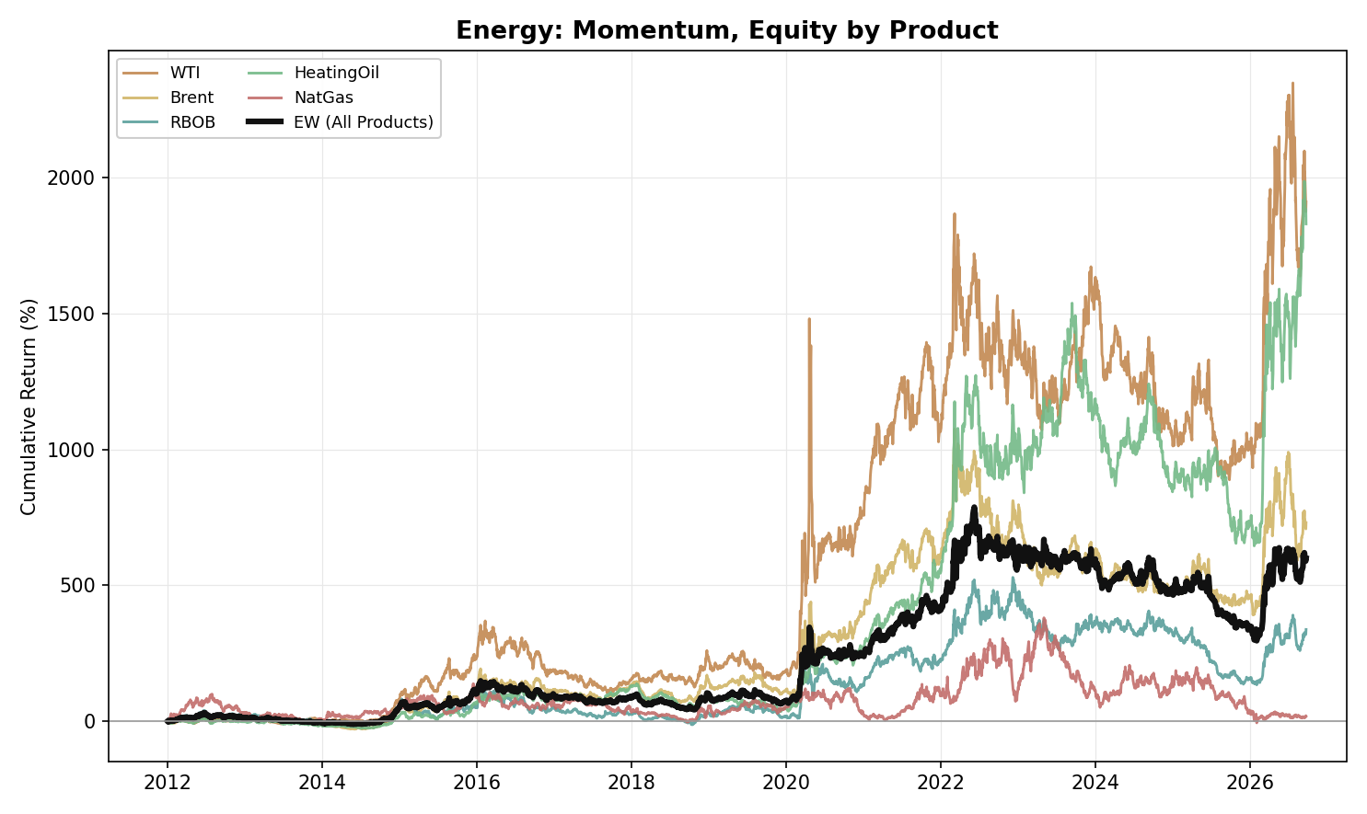
Figure A5. Energy, Momentum: Equity Curve by Product (2012-2026)
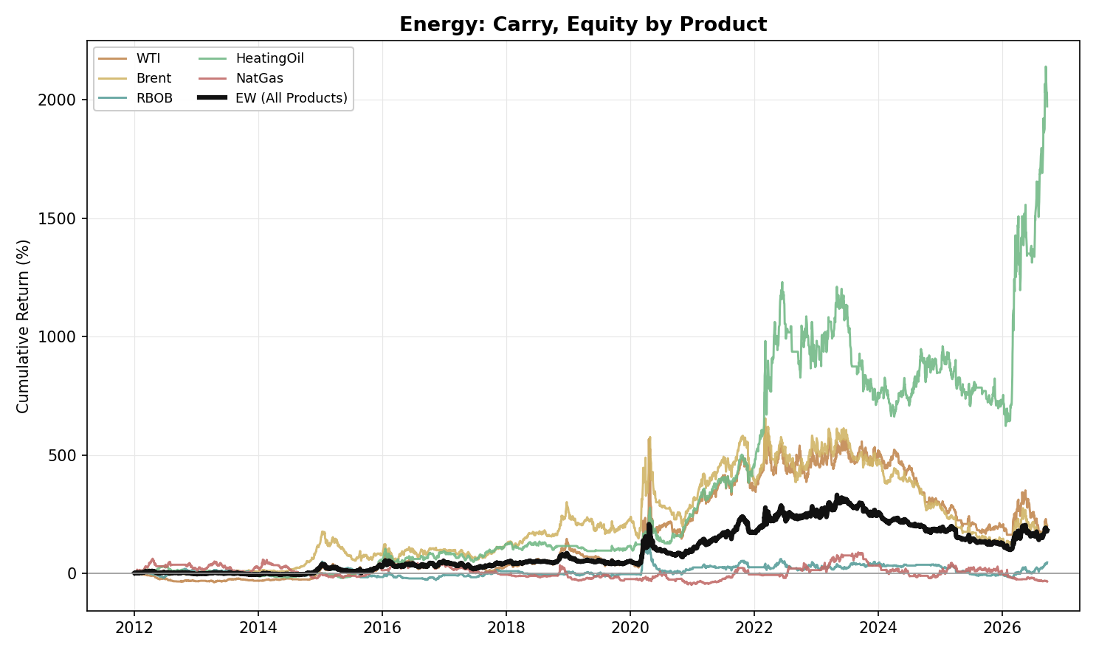
Figure A6. Energy, Carry: Equity Curve by Product (2012-2026)
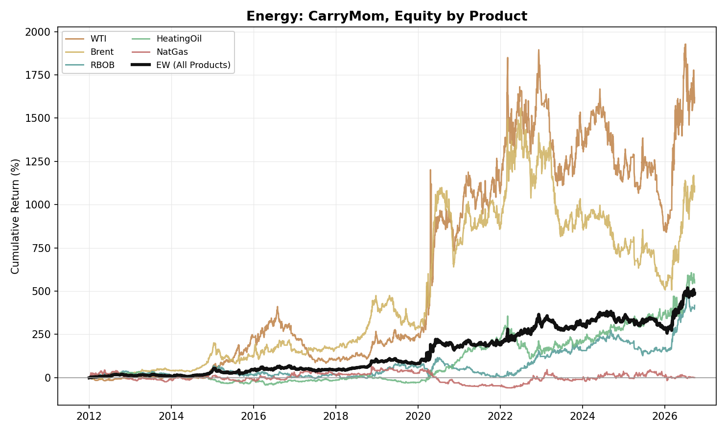
Figure A7. Energy, Carry-Momentum: Equity Curve by Product (2012-2026)
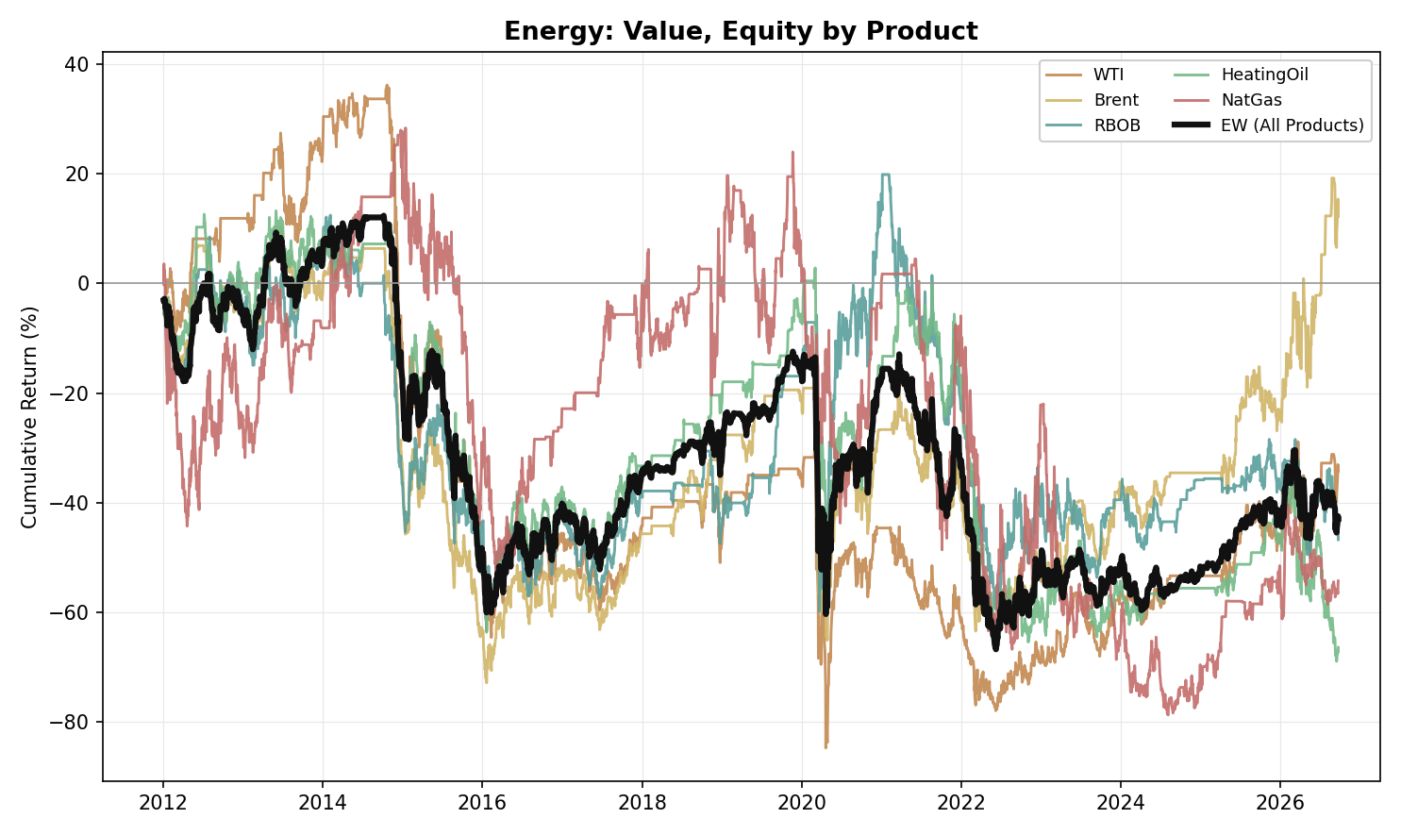
Figure A8. Energy, Value: Equity Curve by Product (2012-2026)

Precious Metals
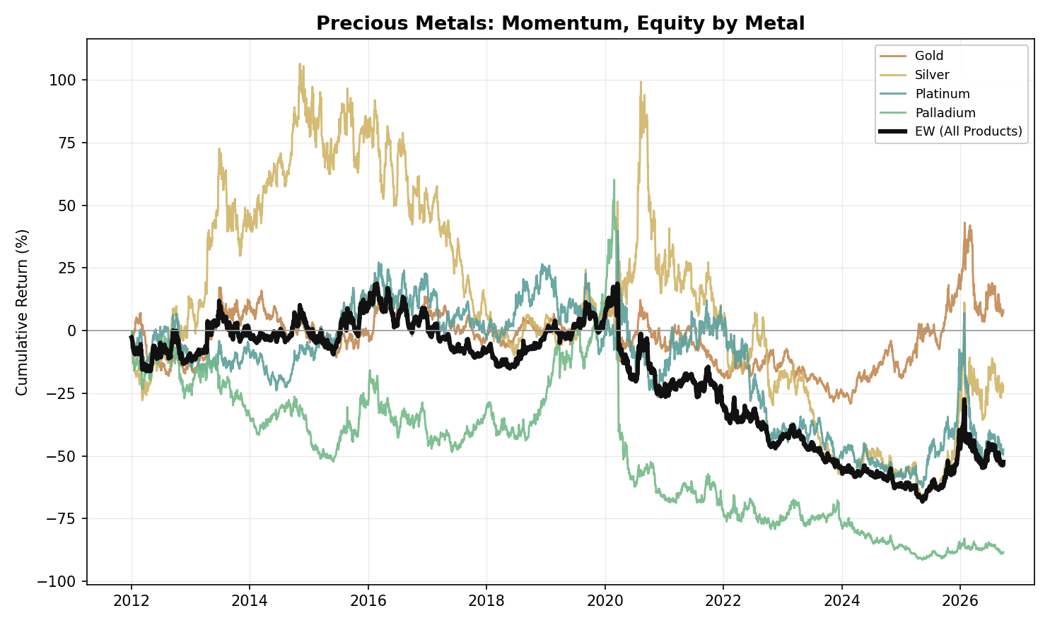
Figure A9. Precious Metals, Momentum: Equity Curve by Metal (2012-2026)
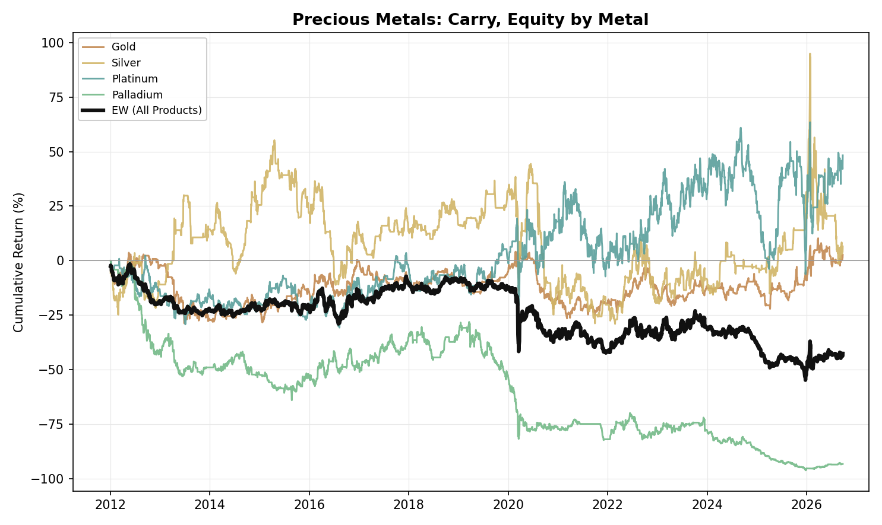
Figure A10. Precious Metals, Carry: Equity Curve by Metal (2012-2026)
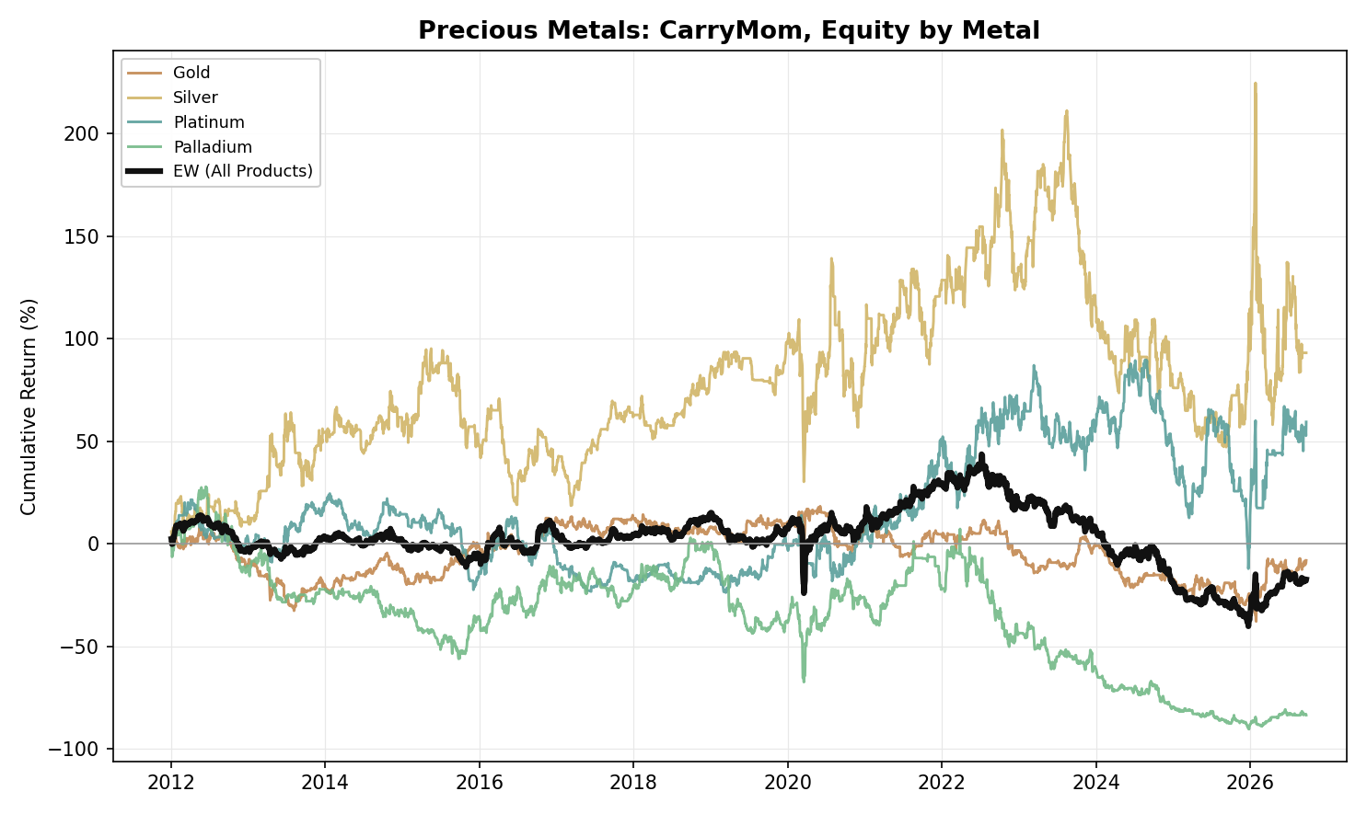
Figure A11. Precious Metals, Carry-Momentum: Equity Curve by Metal (2012-2026)
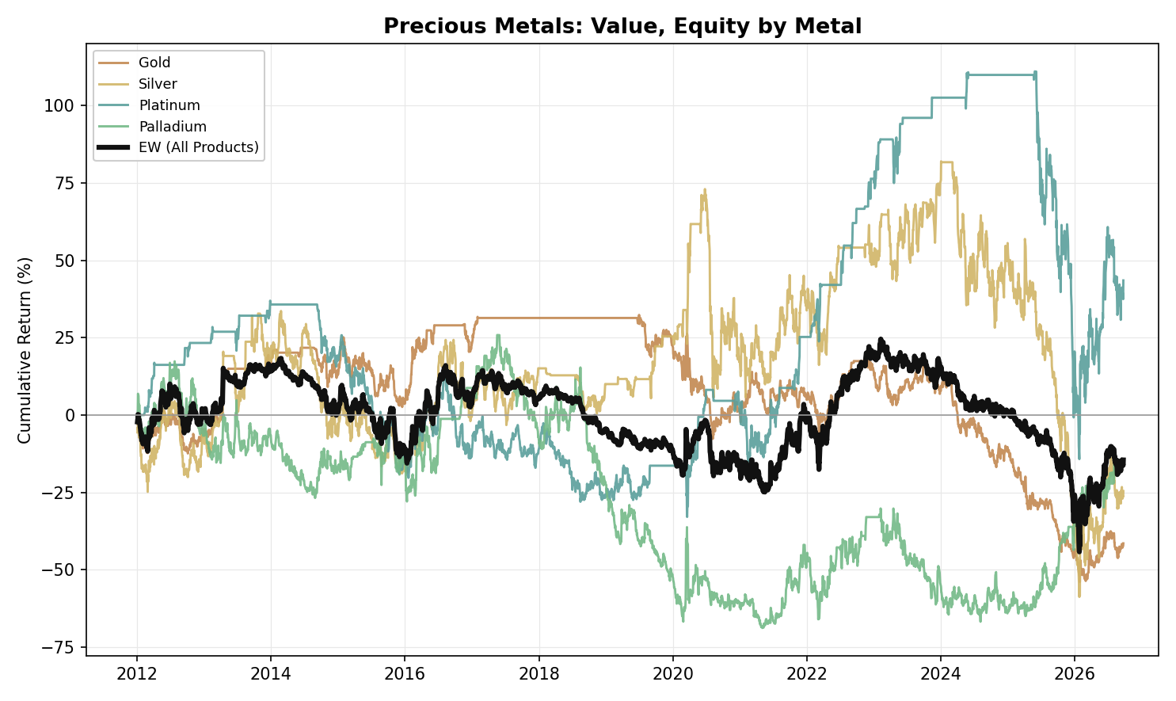
Figure A12. Precious Metals, Value: Equity Curve by Metal (2012-2026)

NGL
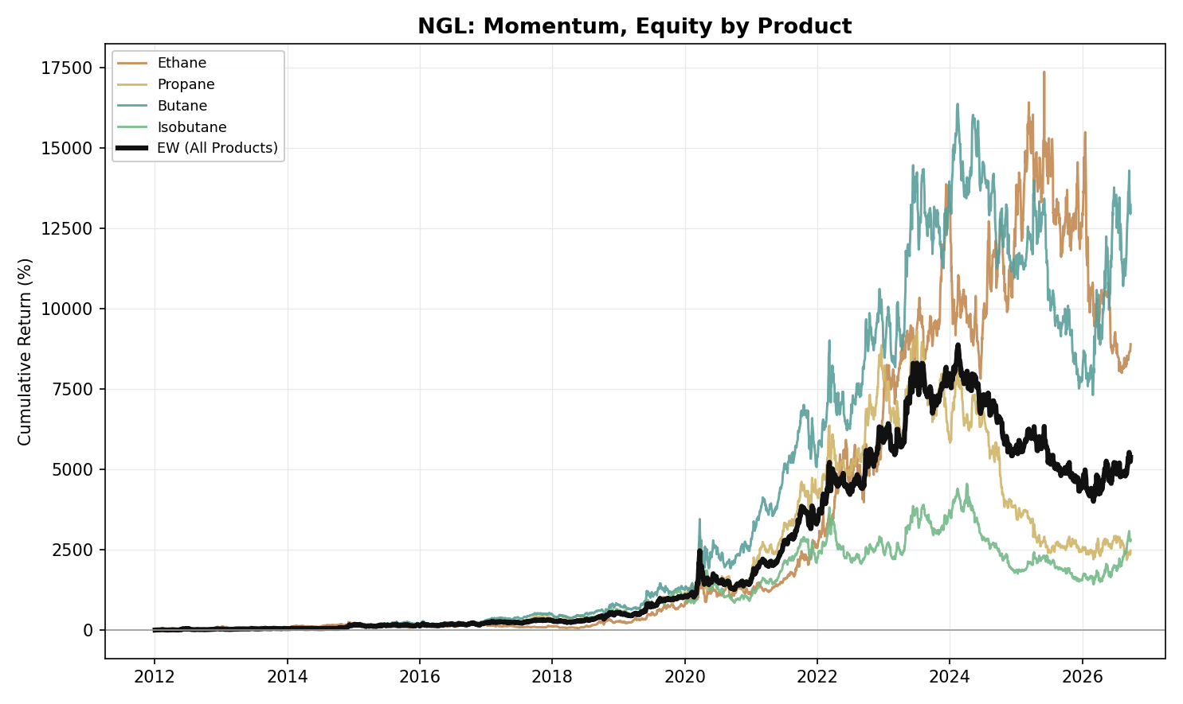
Figure A13. NGL, Momentum: Equity Curve by Product (2012-2026)
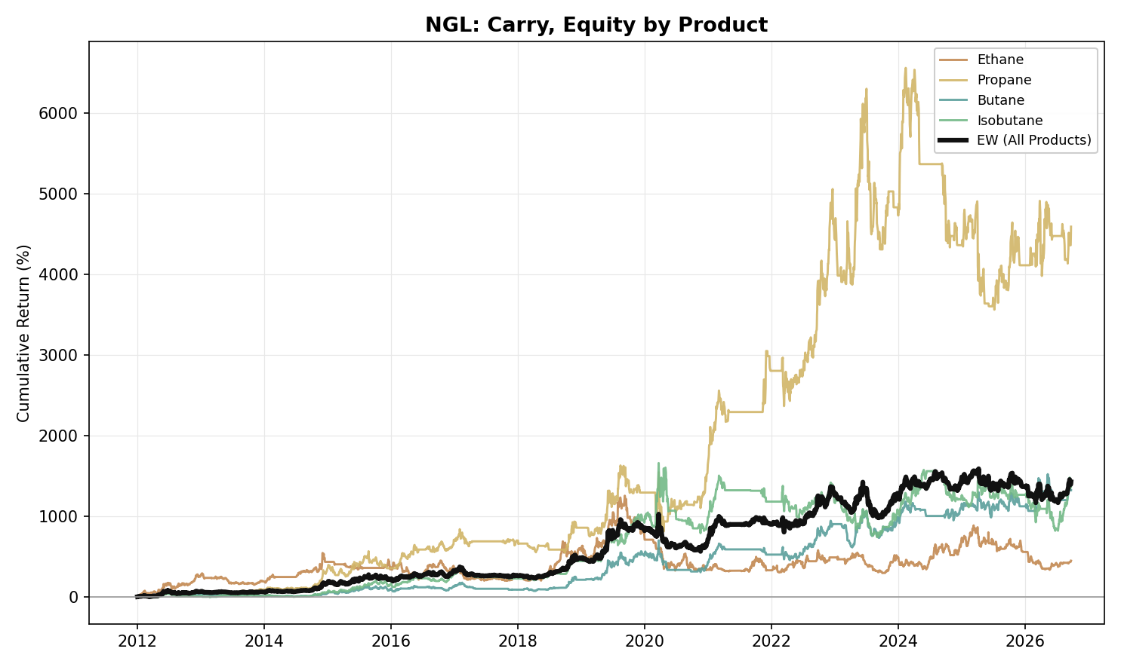
Figure A14. NGL, Carry: Equity Curve by Product (2012-2026)
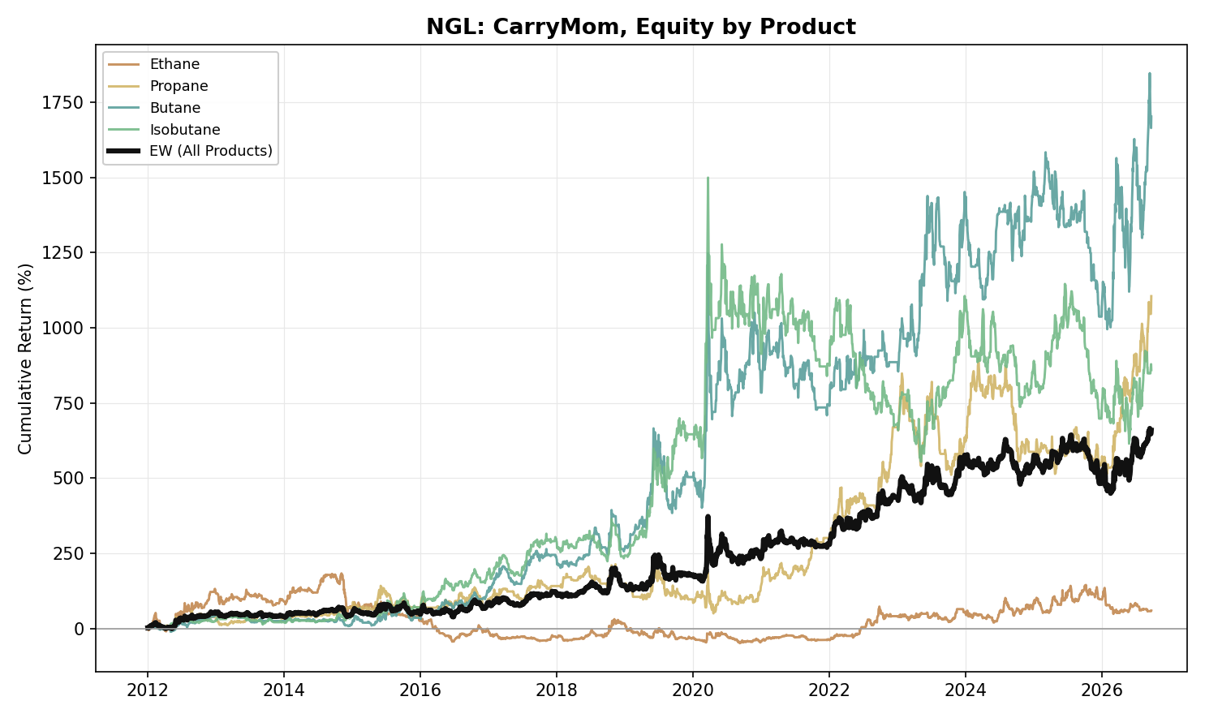
Figure A15. NGL, Carry-Momentum: Equity Curve by Product (2012-2026)
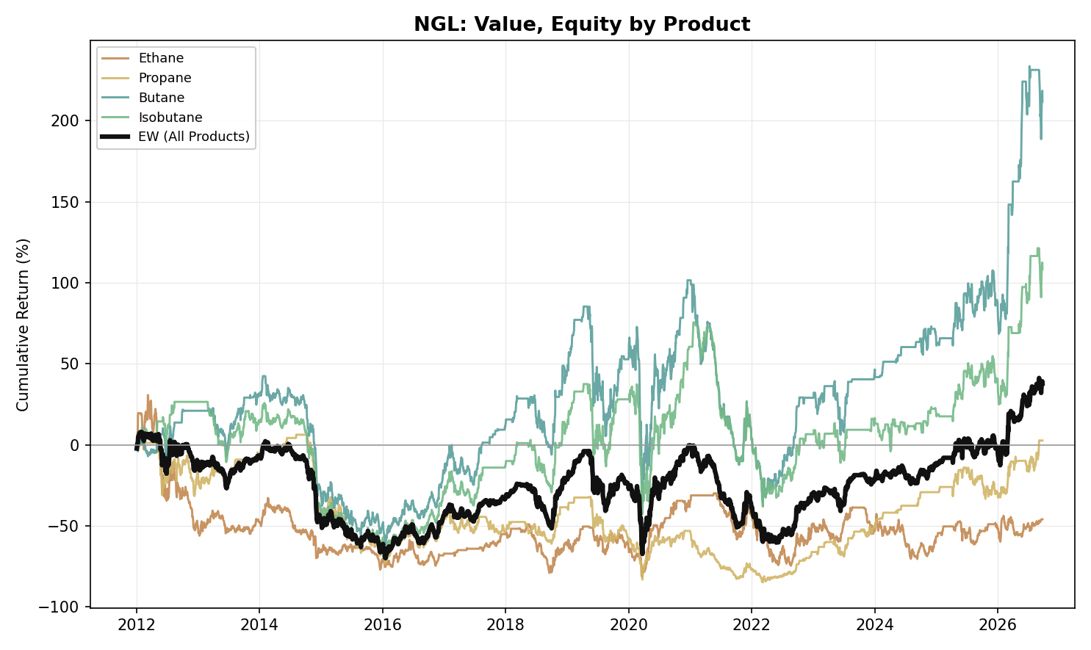
Figure A16. NGL, Value: Equity Curve by Product (2012-2026)

Agriculture
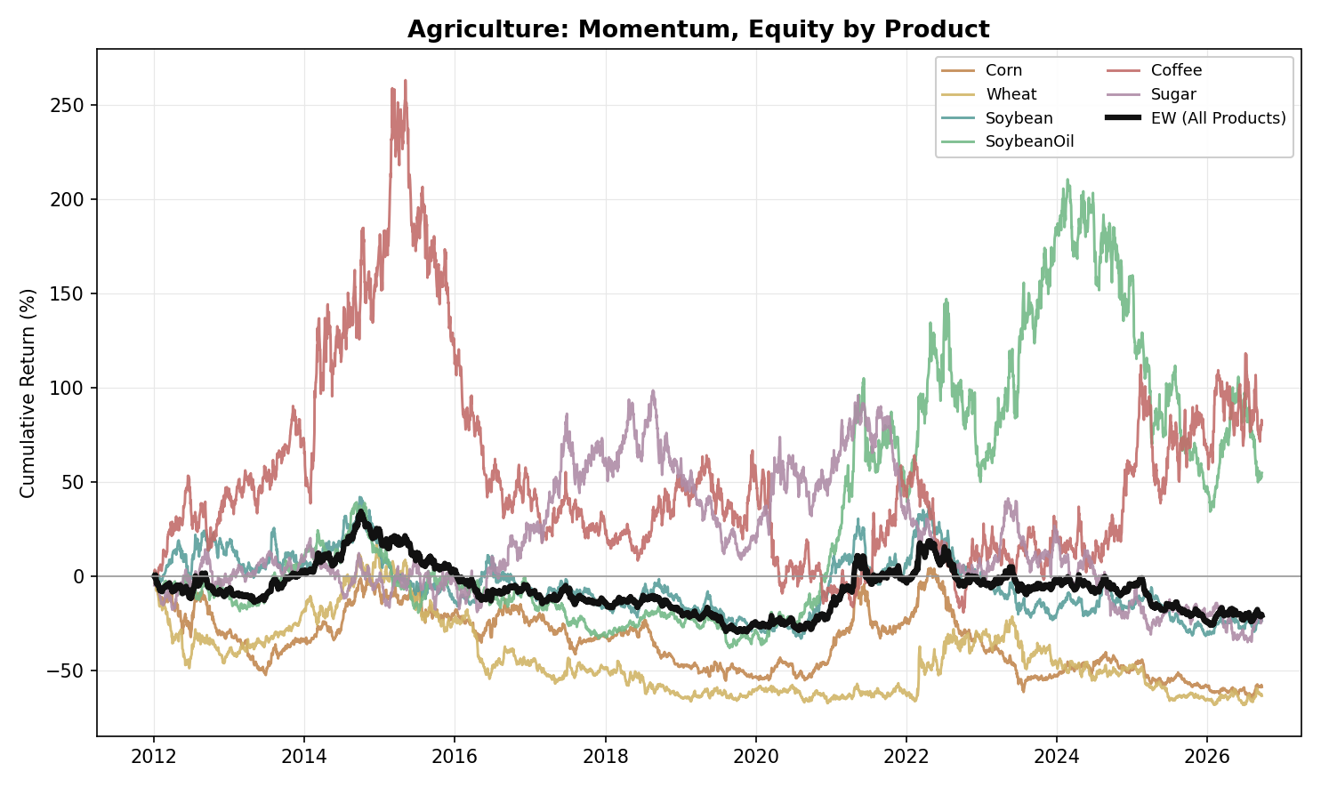
Figure A17. Agriculture, Momentum: Equity Curve by Product (2012-2026)
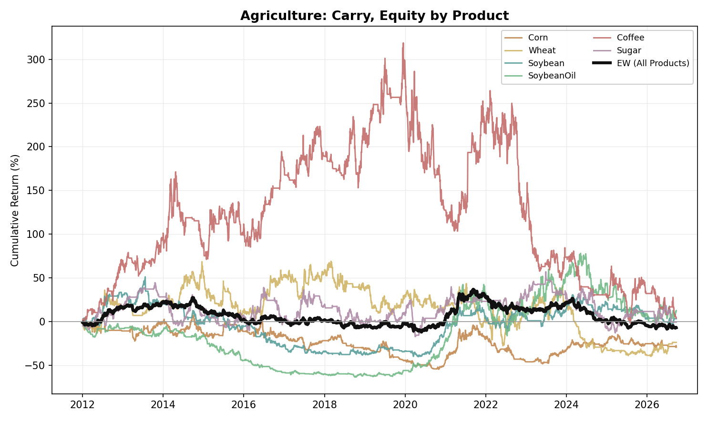
Figure A18. Agriculture, Carry: Equity Curve by Product (2012-2026)
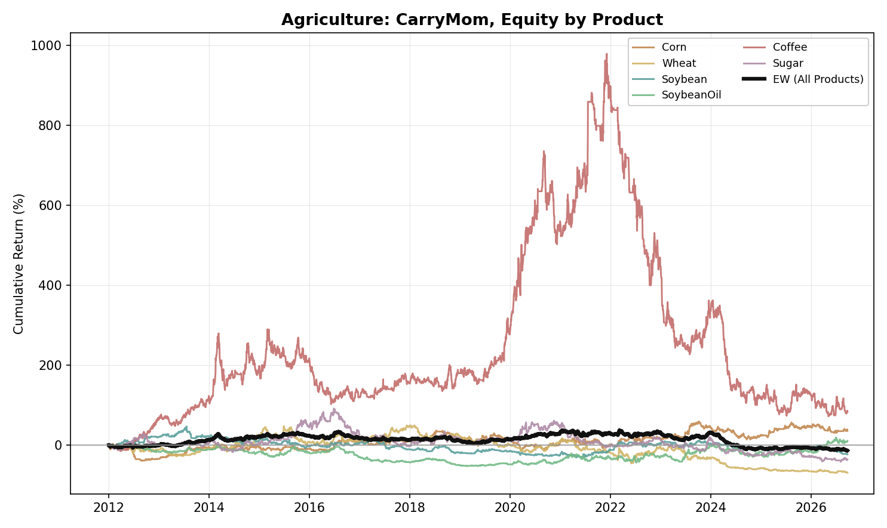
Figure A19. Agriculture, Carry-Momentum: Equity Curve by Product (2012-2026)
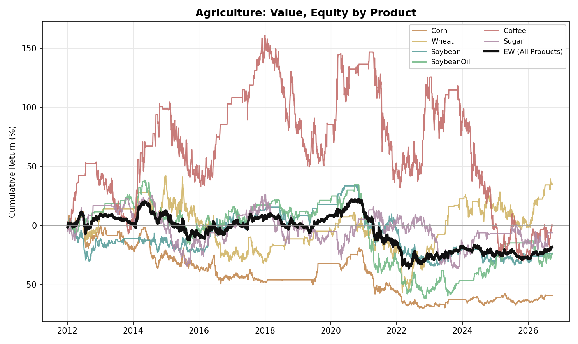
Figure A20. Agriculture, Value: Equity Curve by Product (2012-2026)

Cross-Pair Portfolios
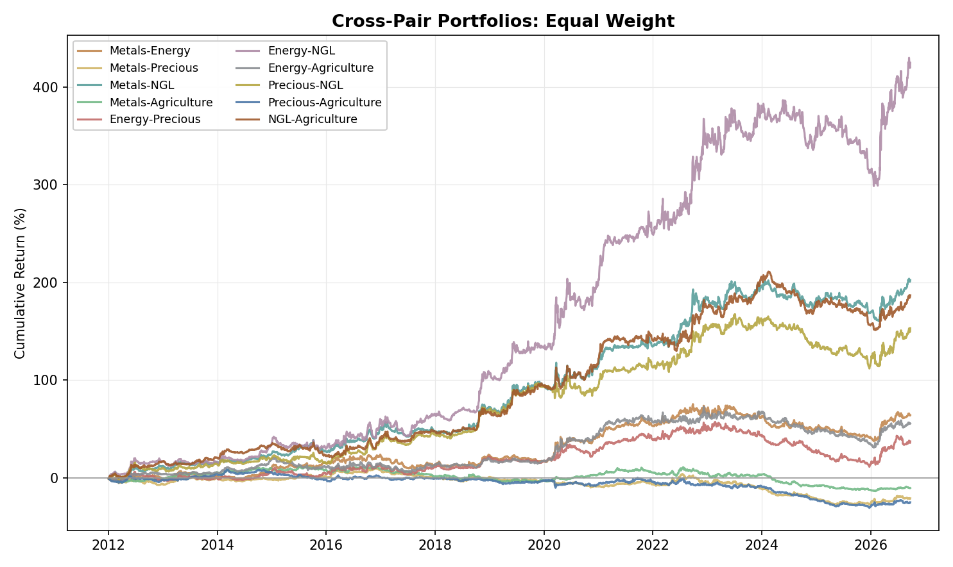
Figure A21. Cross-Pair Portfolios, Equal Weight: Equity Curve by Asset-Class Pair (2012-2026)
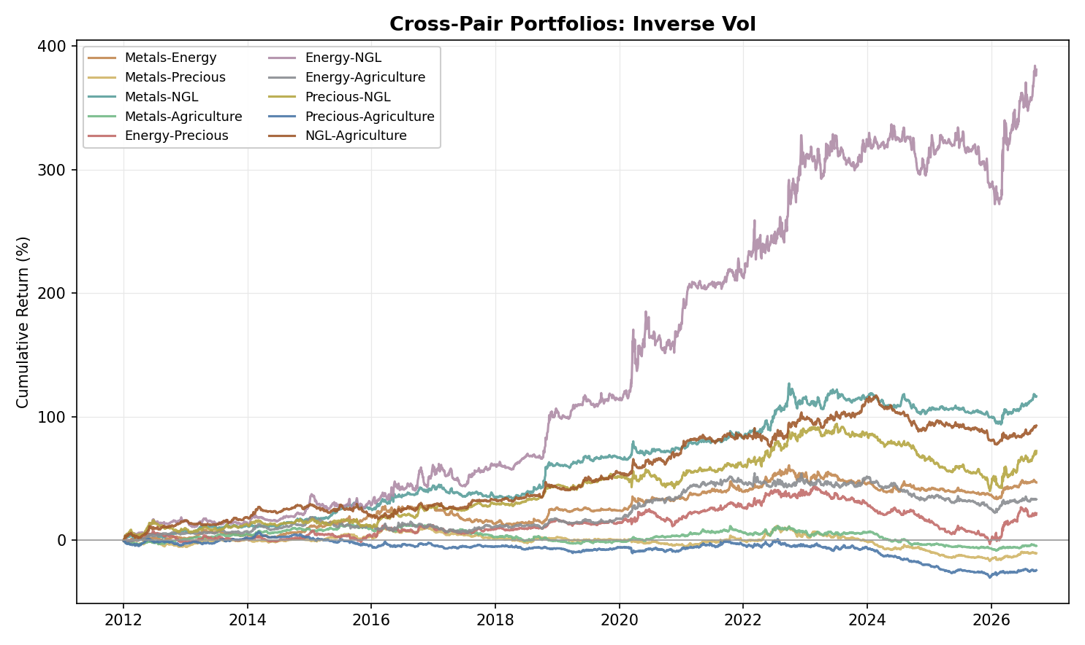
Figure A22. Cross-Pair Portfolios, Inverse Vol: Equity Curve by Asset-Class Pair (2012-2026)

